|  |
| --- |
|  |
| 新概念 3 册 |
| Lesson33 |

Lesson 33 A day to remember

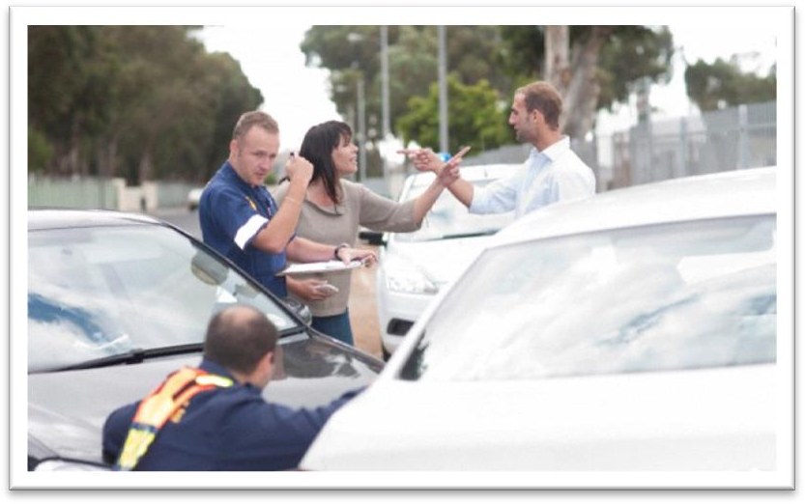

**prelude ['prelju:d]**

**n. 序幕，前奏**

prelude (to sth.)

The high wind is the prelude to a heavy storm. prologue (to …) preface (to …)

foreword (to …) epilogue (to …)

unforeseen [ʌnfɔ:'si:n] adj. 意料之外的

unforeseen unexpected

foresee expect

foretell predict

Timely snow foretells a bumper harvest. forecast weather forecast **series ['sɪəri:z]**

n. 系列

series species

a series of books a series of stamps

A series of rainy days spoiled my vacation. a chain of …

a train of … a trail of … a string of …

a stream of …

catastrophe [kə'tæstrəfɪ]

**n. 大灾难**

mishap

accident contingency disaster

calamity catastrophe

crockery ['krɒkəri]

**n. 陶器**crockery pottery earthenware china chinaware porcelain

suburb ['sʌbɜ:b]

**n. 郊区**

suburb suburban

rural urban

metropolitan cosmopolitan

panic ['pænɪk]

**n. 惊慌**

get into a panic in a panic He fled in a panic.

Don’t panic in case of fire.

panic panicked ~ panicking picnic picnicked ~ picnicking **stray [streɪ]**

adj. 迷路的，偏离的；v. 迷路，偏离

a stray dog / boy / bullet stray sheep

Some of the cattle have strayed. Don’t stray from the point. **confusion [kən'fju:ʒən]**

n. 混乱；迷惑

confuse confused confusing disorder in disorder

mess in a mess

chaos in (a state of) chaos

All the things I had packed so carefully were soon in a dreadful mess.

Without it, nothing could ever be brought to a conclusion; everything would be in a state of chaos.

greedily ['gri:dɪlɪ] adv. 贪婪地

greedy gluttonous

the seven deadly sins:

greed gluttony

lust envy

wrath sloth pride

… to remember

Gandalf, my old friend … this will be a night to remember.

go wrong 出错，出问题，不顺利

We have all experienced days when everything goes wrong. Our marriage began to go wrong after we had our first child. Something’s gone wrong with my computer.

An advertisement which begins with the magic word FREE can rarely go wrong.

It is all too easy to blame the railway authorities when something does go wrong. We have all experienced days when life seems to be a bowl of cherries.

We have all experienced moments of misery and despair. suddenly

all of a sudden all at once

Seeing a cake flying through the air, a lorry driver who was drawing up alongside the car, pulled up all of a sudden.

All at once, I noticed that my wife seemed to be filled with alarm. get out of control / hand

Discuss the situation with the person in charge of the dormitory.

Ask her roommate not to make so much noise.

Go to bed after midnight.

Send a letter to the residents.

W: You know the noise in my dorm has really gotten out of control. My roommate and I can rarely get to sleep before midnight.

M: Why don’t you take the problem up with the dorm supervisor? Q: What does the man suggest the woman do?

Answer: (A) Discuss the situation with the person in charge of the dormitory.

We started burning some leaves in our yard, but the fire got and we had to call the fire department to put it out.

(A) out of hand (B) out of order

out of the question

out of the way get sth. under control

The air will be cleaner if they go to a different city.

It’ll soon be too late to control the pollution.

Society will not pay attention to the new laws.

The situation will improve if changes are made.

M: Look at all the pollution going into the air from those factories. Do you think they’ll ever get that under control?

W: With the new laws and social awareness, we’ll turn things around. Q: What does the woman predict will happen?

Answer: (D) The situation will improve if changes are made.

What invariably happens is *that a great number of things choose to go wrong at precisely the*

*same moment*.

what invariably happens is that … 往往总是…… 造句：往往总是干得最多的人收入最少。

What invariably happens is that those who work most get paid least.

造句：往往总是老师一走班里就陷入一片混乱状态。

What invariably happens is that once teachers leave the class will be in a state of chaos. choose to do

More and more people are choosing to live alone. Catherine chose to ignore the doctor's warning.

It never rains but it pours.

As the old saying goes, happiness comes alone while misfortune loves company. If anything can go wrong, it will. (Murphy’s law)

The heavy fog set up a traffic jam. cause effect

lead to result in

bring about give rise to

produce create

trigger / spark

Even the smallest diplomatic incident can trigger / spark a major international conflict. a series of reactions

a train of reactions a trail of reactions a string of reactions a chain reaction

a domino effect a ripple effect

keep an eye on sth. / sb.

Would you please keep an eye on my suitcase while I’m away? look after / take care of / watch

babysit

He used to babysit for Mary when she worked nights. babysitter

The doorbell rang. ring the doorbell go off

The alarm clock went off. strike

The clock is striking the hours. The clock began to strike twelve.

It marked the end of the great tradition of ships with sails and the beginning of a new era.

The foundation of the People’s Republic of China marked the beginning of a new historical period in China.

mark the prelude to …

The dark clouds marked the prelude to a heavy storm.

The Lugouqiao Incident marked the prelude to China’s War of Resistance Against Japanese Aggression.

While you are on the phone, the baby pulls the tablecloth off the table, *smashing half your best crockery and cutting himself in the process*.

be on the phone answer the phone

While you are answering the phone, … answer the door

I’ll get it.

May I speak to Mr. John Smith? This is John Smith speaking.

This is he.

Speaking.

Who is it?

Who is there?

Who is calling?

One moment, please. Hold on / Hang on, please.

John, there’s a phone call for you. John, you are wanted on the phone.

John, Tom’s on the line. Pick up the phone on your desk.

Sorry, Mr. Smith is in a meeting right now. Would you like to leave a message / May I take a message?

Can you connect me with John Smith in the advertising department? I’d like to place / make a collect call to Australia.

The connection is very bad. I can barely hear you.

There’s something wrong with the phone. Let’s hang up. I’ll call you right back. He studied very hard (only) to fail the exam.

The firefighters raced up the building, (only) to be the first victims.

Farm labourers said that they always woke up to find that work had been done overnight. in the process: at the same time

I stood up to say hello and spilt my drink in the process. hang up

put the phone down slam the phone down get cut off

Eating in a cafeteria.

Buying something in a store.

Talking on the telephone.

Getting money at a bank. M: Did you get cut off?

W: No, they asked me to hang up and try again later.

Q: What has the woman been doing? Answer: (C) Talking on the telephone. hurriedly in a hurry / rush in haste

There’s no hurry / rush. What’s the hurry / rush? Take your time.

Excuse me, ma'am. Ticket, please.

Would you kindly hold these keys, please? I have a ticket, I know. I was in the smoking section. It's OK, lady. Take your time.

et cetera (etc.) and so on

and so forth and the like and what not meanwhile

at the same time in the process

(in the) meantime

As if this were not enough to reduce you to tears, your husband arrives, *unexpectedly bringing three guests to dinner*.

'Oh, that,' he said with a smile as if he were talking about an old friend. Don’t act as if you were the only pebble on the beach.

reduce sb. to sth. reduce sb. to tears reduce sb. to despair reduce sb. to silence

unexpectedly / unforeseenly

Things can go wrong on a big scale, *as a number of people recently discovered in Parramatta, a suburb of Sydney*.

on a small scale on a limited scale

on a big / large / great / grand / vast scale

on a colossal / huge / enormous / immense / gigantic scale on a national / nationwide scale

on a global / international / worldwide scale

as 引导的非限定性定语从句与 which 引导的非限定性定语从句的区别。

1、as 作为关系代词指代整个主句，而 which 作为关系代词指代整个主句或先行词均可。

2、as 引导的非限定性定语从句位于主句前、中、后均可，而which 引导的非限定性定语从句不能位于主句之前。

As a poet points out, life is but a dream. Children, as is always the case, love their mother. She became angry, as many could see.

3、as 引导的非限定性定语从句含有“众所周知”的意思，常译为“正如……”，而which 引导的非限定性定语从句则未必有这个意思。

The sun heats the earth, which makes it possible for plants to grow.

4、在“as + is/was + done”结构中可省略“is/was”，而在 “which + is/was + done”可省略“which + is/was”，而不能只省略 be 动词。

As (is) reported, a foreign delegation will visit the city. a puma (which was) at large

As Napoleon once pointed it out, attack is the best method of defense.

As Napoleon once pointed it out, attack is the best method of defense. X As Napoleon once pointed out, attack is the best method of defense. √ the morning / evening rush hour

Don't travel at rush hour.

When the traffic was very heavy, …

The woman immediately behind the two cars happened to be a learner. immediately behind / above / below / in front of sth.

… happened to be a learner.

… chanced to be learner.

It happened / chanced that the woman immediately behind the two cars was a learner. As it happened / As luck would have it, the woman immediately behind the two cars was a learner.

She got into a sudden panic and stopped her car. She stopped her car in a sudden panic.

brake hard / sharply slam on the brakes

stop draw up pull up

Seeing a cake flying through the air, a lorry driver who was drawing up alongside the car, pulled up all of a sudden.

come to a stop / halt

It came to a stop outside the jeweler's.

Bruce charged at it, but in the middle, the car came to a grinding halt.

Seeing a cake flying through the air, a lorry driver *who was drawing up alongside the car*, pulled up all of a sudden.

draw up

A taxi drew up at the gate. draw sth⇔up

…, when the Marquis of Queensberry drew up the first set of rules. alongside adv. & prep.

A car drew up alongside.

A police car pulled up alongside us.

… slid off the back …

… slipped off the back …

The lorry was loaded with empty beer bottles and hundreds of them slid off the back of the

*vehicle* and on to the road.

Giant pandas are considered a national treasure and the Chinese government are doing their best to protect this *endangered species*.

Moreover, in the past two years other nearby cities may have begun to build similar golf courses or resort hotels. Indeed, the fact that Ocean View has already built *these facilities* might actually portend failure for Hopewell, …

yet / still (another / one more…) yet one more question

still another example

He sent yet another fax informing the journalist that if he did not reply soon he would be fired. pile up

The work just keeps on piling up and makes me want to scream.

It took the police nearly an hour to get the traffic on the move again. The police took nearly an hour to get the traffic on the move again.

The police spent nearly an hour (in) getting the traffic on the move again.

on the + noun. 处于某种状态

The dog is on the alert. He is always on the go.

The patient is on the recovery. Crimes are on the rise.

While you are on the phone, …

Even people who take no interest in art cannot have failed to notice examples of modern sculpture on display in public places.

The house is on sale.

The workers are on strike. I’m here on vacation.

I’m here on business.

The nurse is on call 24 hours a day.

Only two stray dogs benefited from all this confusion, for they greedily devoured *what was left of the cake*.

benefit from … 得益于…… benefit … 有益于……

This food will benefit your brain. Your brain will benefit from this food.

what is left of sth. = what remains of sth.

…, for they greedily devoured what remained of the cake.

It is recounted of Thomas Carlyle that when he heard of the illness of his friend, Henry Taylor, he went off immediately to visit him, carrying with him in his pocket what remained of a bottle of medicine formerly prescribed for an indisposition of Mrs. Carlyle's.